Exploratory Data Analysis (EDA) Report

1. Data Cleaning
Missing values removed
Duplicates removed

2. Outlier Detection
Boxplot analysis revealed outliers in student marks and school fees
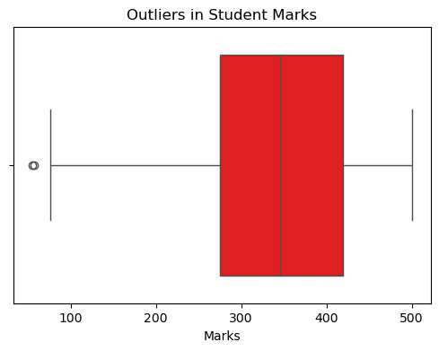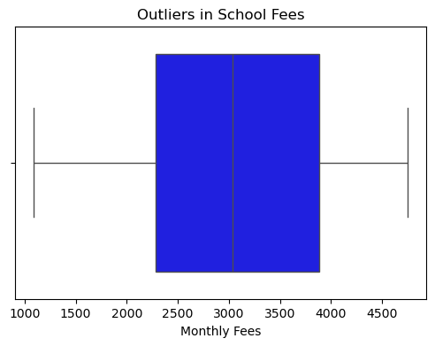

3. Distribution of Monthly Family Income
Majority of families have a monthly income between 10,000 and 50,000
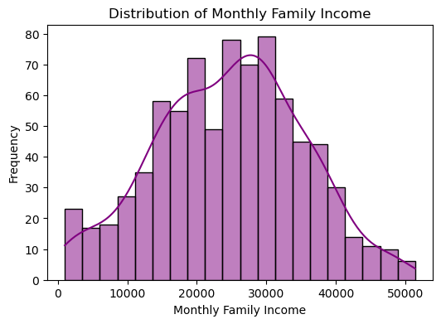
9% of families have an income below 10,000

4. School Performance Analysis
Schools show varying average marks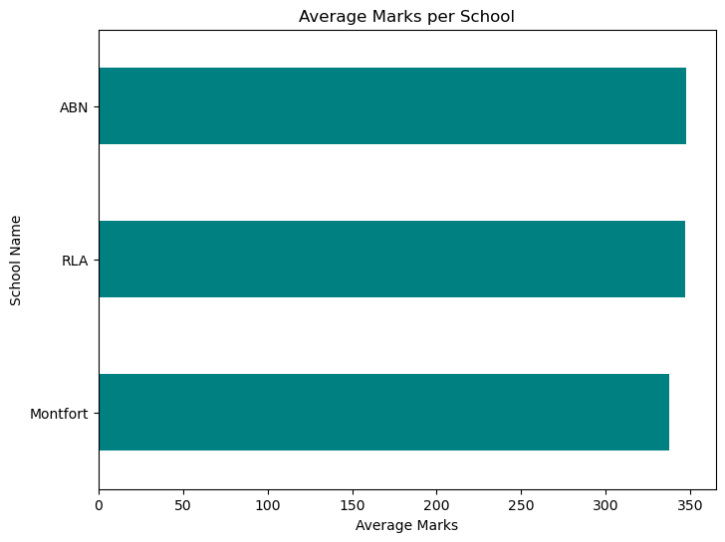
The highest performing school has an average score of 375.24
The lowest performing school has an average score of 322.4

5. Age vs. Student Marks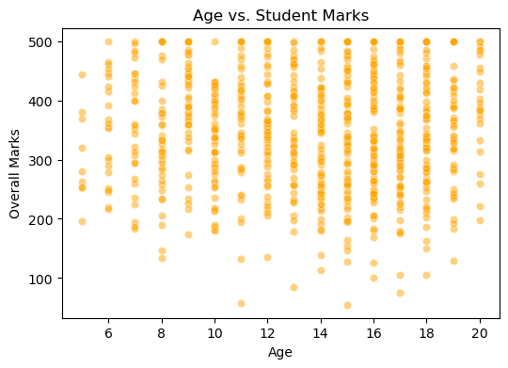
Almost no correlation between age and student performance (-0.026)

6. Fee Affordability Analysis
19% of students cannot afford school fees as they exceed 20% of family income

7. Failure Rate Per Class
Class 2 has the highest failure rate (10% of students failed)

8. Correlation Analysis
Correlation Matrix:
Monthly_Fees Overall_Marks Monthly_Family_Income
Monthly_Fees 1.000000 -0.050964 -0.022160
Overall_Marks -0.050964 1.000000 -0.039248
Monthly_Family_Income -0.022160 -0.039248 1.000000

School Fees vs. Marks: Weak negative correlation (-0.051)
Family Income vs. Marks: Negligible correlation (-0.039)
Family Income vs. School Type: Very weak correlation (0.018)

9. Conclusion & Suggestions
Family income has minimal influence on student performance and school selection
Higher school fees do not guarantee better academic results
Schools should focus on quality of education rather than fees to improve student outcomes

